# Lesson 1: The Development of the Periodic Table

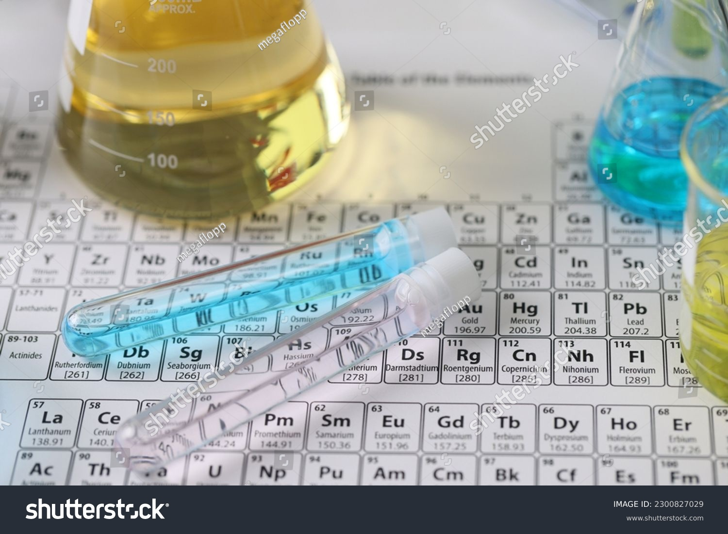

Figure 5.1. Development in periodic table

# <H1> **Essential Question**

How has the periodic table evolved into a powerful tool for understanding elements and their properties?

<H1> Big Idea  
The periodic table was developed through the contributions of several scientists, and it organizes elements based on atomic structure and repeating chemical properties.

<H1> Lesson Objectives  
By the end of this lesson, I will be able to:

Name key scientists who contributed to the periodic table.

Outline the principles behind the organization of the periodic table.

* Compare and contrast the early periodic tables with the modern periodic table.

<H1> Curiosity Corner  
  
In northern countries, during the cold, freezing winters, roads are covered with ice. At such times, salt is spread to melt the ice, making the road safer. But why do you use different salts, like sodium chloride, magnesium chloride, or calcium chloride instead of just one? According to the position of elements in the periodic table, how are they different? What makes these elements behave similarly or differently?  
The salts which are used for deicing purpose are made up of a common “chloride” part, but they differ in the metal element (sodium, magnesium, or calcium). These metals have different properties than non-metals (like chloride). Is there a way to organize the elements and predict their properties?  
  
  
<H1> Key Vocabulary

Atomic mass- The weighted average mass of an atom of an element, accounting for its different isotopes and their abundance.

Atomic number- the number of protons in an atomic nucleus

Atomic weight- Often used interchangeably with atomic mass, though it typically refers to the average mass of atoms of an element, expressed in atomic mass units (u).

Mendeleev- Dmitri Mendeleev, a Russian chemist, developed the first widely recognized periodic table based on atomic mass and predicted undiscovered elements.

Modern periodic table- The arrangement of elements by increasing atomic number, reflecting their properties and reactivity patterns.

Moseley- Henry Moseley, an English physicist, showed that organizing elements by atomic number rather than atomic mass corrected previous inconsistencies in the periodic table.

<H1> Ignite: **The Periodic Table**  
  
Direct Instruction: The periodic table is a powerful tool that organizes all the elements. It evolved over time as scientists discovered more about atomic structure. Early attempts to arrange elements were based on their atomic mass, but this led to some inconsistencies. The modern table is based on atomic numbers, a more accurate way to order elements. Elements in the same group (vertical columns) have similar properties, which helps us predict how they will behave chemically.

For example, understanding the periodic table allows us to predict why magnesium, calcium, and sodium exhibit different behaviors when they form compounds with chloride.

<H2> Progress Check 1

How did the shift of elemental parameters from atomic mass to atomic number improve the accuracy of the periodic table?

<H1> Pathfinder: Organizing Atoms

Given the following atoms, propose a way to organize them in a chart so that the chart is useful to predict the elements’ properties.

Al, Ar, B, Be, Br, C, Ca, Cl, F, H, He, Li, K, Mg, N, Na, Ne, O, P, S, Si

The Development in the Periodic Table was Carried Out by Many Scientists and Spanned Several Decades. Here’s a Breakdown of How It Happened and Why It’s Important.

<H1> Lightbulb: Mendeleev’s Contribution

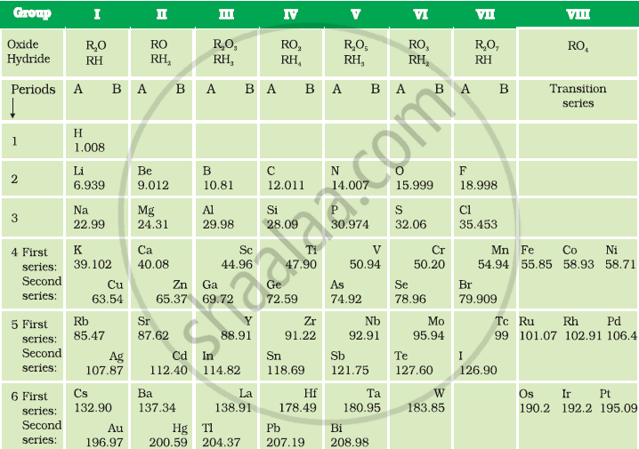

Figure 5.2. Mendeleev periodic table

In 1869, Dmitri Mendeleev, a Russian chemist, was trying to organize the known elements in a way that made sense. At the time, about 63 elements were known, and their properties were often puzzling. Mendeleev arranged the elements by increasing atomic mass. He noticed that elements with similar properties appeared at regular intervals, and this led him to create the first version of the periodic table.  
  
Mendeleev’s table had some gaps, but he was bold enough to predict that these gaps represented elements that hadn’t been discovered yet. When these elements were later found, they fit perfectly into Mendeleev’s table, proving that his system worked well – for the most part.  
  
However, there were some issues. A few elements didn’t seem to fit properly when ordered by atomic mass. For example, iodine (atomic mass: 126.90 u) was placed after tellurium (atomic mass: 127.60 u) which appeared wrong order according to their atomic masses, but the positions were right as per their physical and chemical properties.  
  
**Sample Problem:**  
Suppose you arrange the elements lithium (Li), beryllium (Be), and boron (B) based on atomic mass. Predict the element that would come next based on Mendeleev’s arrangement.  
  
<H2> Progress Check 2  
Given the following elements arranged by atomic mass: lithium (Li), potassium (K), and rubidium (Rb), predict which element might come next.  
  
  
 <H1> Moseley’s Contribution

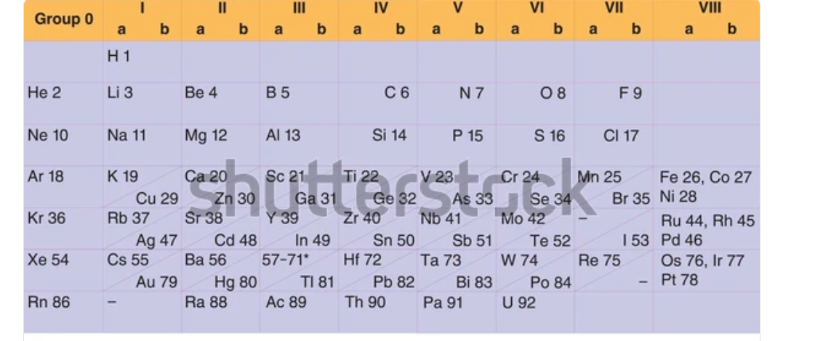

Figure 5.3. Moseley periodic table

In 1913, Henry Moseley, an English physicist, discovered that the periodic table should be arranged according to atomic number, instead of atomic mass. Moseley used X-ray experiments to show that each element has a unique number of protons in its nucleus. This number, called the atomic number, is a more accurate way to organize the elements.  
  
When the elements were arranged by atomic number, the inconsistencies in Mendeleev’s table disappeared. Elements that seemed out of order according to their atomic masses, like tellurium (atomic number: 52) and iodine (atomic number 53) in group numbers 16 and 17, respectively, were placed in the fifth period where these elements were then found to be in their correct position.

<H2> Progress Check 3  
Given the atomic numbers of sulfur (16) and chlorine (17), predict which element comes next in the periodic table when arranged by atomic number.  
  
  
 <H1>The Modern Periodic Table

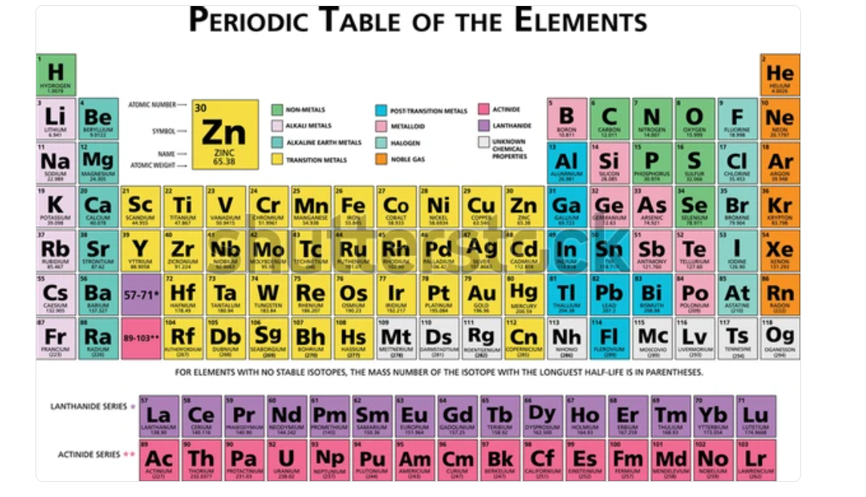

Figure 5.4. Modern periodic table

### The modern periodic table is a systematic arrangement of all known chemical elements, organized by increasing atomic number. It serves as a significant tool in chemistry and provides insights into the properties, behaviors, and relationships of elements. Here’s a detailed look at its structure and significance.

### This understanding helps to predict which salts are the most effective for deicing purposes, as seen with sodium chloride, magnesium chloride, and calcium chloride. The performance differences of these metal ions for deicing is according to their positions in the periodic table and their atomic structure.

### <H2> Structure of the Modern Periodic Table

### <H3> Rows and Columns:

The periodic table is organized in periods and groups. The horizontal rows in the table are called periods. There are seven periods in the modern periodic table. As one moves from left to right across a period, the atomic number increases and elements exhibit a progression of properties.

The vertical columns are known as groups or families. Elements in the same group share similar chemical properties as they have the same number of electrons in their outermost shell. For example, Group 1 contains alkali metals, which are highly reactive and have one electron in their outermost shell.

### <H3> Blocks:

The periodic table can also be classified into blocks based on electron configuration:

s-block: Groups 1 and 2, including helium.

p-block: Groups 13 to 18.

d-block: Transition metals, located in the center of the table.

f-block: Lanthanides and actinides, placed below the main table.

#### <H3> Metals, Nonmetals, and Metalloids:

Elements are classified into three main categories:

Metals: These elements are found on the left side and in the center; typically, shiny, conductive, and malleable (e.g., iron, copper).

Nonmetals: Located on the right side; they are often dull, insulators, and can be gases or brittle solids (e.g., oxygen, sulfur).

Metalloids: Found along the “staircase” line that separates metals and nonmetals; they exhibit properties of both categories of metal and nonmetal (e.g., silicon, arsenic).

### <H2> Key Features of the Modern Periodic Table

**Atomic Number:**

Each element is represented by its atomic number, which corresponds to the number of protons in its nucleus. This arrangement corrects the inconsistencies found in earlier tables that were organized according to atomic masses.

**Electron Configuration:**

The periodic table provides insights into the electron configurations of elements, which helps predict their chemical behavior. Elements in the same group have similar valence electron configurations, leading to similar reactivity.

For example, knowing that magnesium and calcium have two electrons in their outer shell helps us understand their behavior when forming compounds with chloride, explaining why magnesium chloride and calcium chloride might be more or less effective at melting ice.

**Periods and Groups:**

The number of periods in the modern periodic table is seven and these are laid in horizontal rows indicating the direction of the periodic table from left to right across the line where the properties of elements are gradually changed.

The modern periodic table carries 18 groups where Group 1 starts with alkali metals which are highly reactive, and Group 18 ends up with noble gases which are highly inert in the vertical column line where the elements exert similar chemical properties.

### L****anthanides and Actinides****

The fifteen elements in the Lanthanide and Actinide series are mentioned in separate boxes depicting their almost similar physical and chemical properties in the periodic table. The elements Lanthanum (atomic number 57) to Lutetium (atomic number 71) are known as the Lanthanide series. Actinium (atomic number: 89) to Lawrencium (atomic number: 103) are known as actinide series in the modern periodic table.

### ****Transition Metals****

The modern periodic table contains one of the most important features of transition metals which is also known as d-block elements. Groups 3 to 12 carry these elements in the periodic table having properties of metals, the ability to form multiple oxidation states, complex ions formation, etc.

### ****Noble Gases****

The octet-fulfilled elements in the periodic table are known as noble gas elements and reside in Group 18, for example, helium, neon, and argon. These elements are highly stable due to their stable electron configuration and hence unreactive. These unique properties make them suitable for the application of inert environments and lighting.

## <H2>Importance of the Modern Periodic Table

**Predictive Power:**

The periodic table allows scientists to predict the properties and behaviors of elements based on their position. For example, elements in Group 17 (the halogens) are known to form salts when they react with metals.

**Chemical Trends:**

Trends such as electronegativity, ionization energy, and atomic radius can be observed within the table. For instance, electronegativity generally increases from left to right across a period and decreases down a group.

**Understanding Compounds:**

By knowing the properties of elements, chemists can predict how different elements will combine to form compounds. This understanding is fundamental to fields such as material science, medicine, and environmental science.  
  
**Solved Question:**

Why are elements in the same group of the periodic table likely to have similar chemical properties?

**Answer:** Elements in the same group have similar chemical properties because they have the same number of electrons in their outermost shell (valence electrons). This similarity in electron configuration determines how they react with other elements. For example, alkali metals in Group 1 all have one valence electron, making them highly reactive.

<H1> Lesson Check

1. How does the arrangement of elements by atomic number resolve the inconsistencies found in earlier tables that were organized by atomic mass?
2. Explain how the organization of the periodic table according to the atomic number improved the accuracy and predictability of element properties compared to earlier versions arranged by atomic mass. Include examples of elements that were reordered correctly.
3. Discuss the significance of electron configuration in the periodic table. How does the arrangement of electrons determine the reactivity and chemical properties of elements in the same group?
4. Explain the concept of periodic trends and how they vary across periods and groups. Provide examples of how these trends can be used to predict the behavior of elements.

## <H1> Beyond the Lesson

To deepen understanding of the periodic table, explore how its principles apply to real-world challenges and innovations. Investigate how scientists have used the periodic table in the development of new materials, such as lightweight alloys for airplanes or superconductors for advanced electronics. Consider the role of elements in emerging technologies, like renewable energy sources, and examine how the properties of elements influence their application in solar panels or batteries. Additionally, revisit key concepts such as electron configuration and periodic trends by comparing different elements' behaviors in various chemical reactions. Use this knowledge to predict and explain why certain materials are better suited for specific purposes, such as corrosion resistance or conductivity.